OAHN PROJECT SUMMARY
Project #: 009115
Project Title: Investigate the increase of swine erysipelas as reported by several data sources compiled by the OAHN Swine network
Project Lead: Tim Pasma, Sue Burlatschenko
Collaborators:
Durda Slavic, Jim Fairles, Josepha Delay (Animal Health Laboratory)
Andrew Vince, Manjusri Wijekoon (OMAFRA)
Kalena Statutiak, Guy Moser, Anna Pietruszkiewicz (Gallant Custom Laboratories)
Colleen Roehrig (Conestoga Meats)

Start date: Nov. 2018 End date: Jan. 31 2020

Executive Summary
Please provide a 1-2 paragraph abstract describing the project, its methods/results, outcomes, future applications and next steps. This will be used as a descriptor of your project on the OAHN website.
Since the fall of 2015, the OAHN Swine Network has noted an increase in activity of swine erysipelas, based on data from practitioners completing the quarterly survey and from provincial and federal slaughter plants. The purpose of this study was to isolate and, using whole genome sequencing (WGS), to characterize isolates of swine erysipelas from abattoirs and swine farms in Ontario. During 2019 tissue samples (e.g., lung and spleen) were collected from hogs in slaughterhouses and clinical cases in Ontario with lesions suspicious for swine erysipelas and submitted to Animal Health Laboratory (AHL) for culture. In total 8 cases were received comprising of 25 samples. Eleven samples were collected from clinical cases whereas 14 samples were from slaughterhouses. Only 6 isolates of Erysipelothrix rhusiopathiae were recovered from the samples submitted (3 from the clinical cases). To compensate for low number of isolates recovered, E. rhusiopathiae isolates conveniently archived by the AHL (5) and Gallant Custom Laboratories (3) were also included in the study bringing up the total number of isolates for sequencing to 14. Based on limited data available for each isolate it is likely that isolates originated from 11 different premises but that cannot be confirmed. Most of isolates sequenced were archived isolates recovered in 2015 (1), 2016 (2) and 2018 (5).
Isolates were sequenced on Illumina MiSeq using Nextera XT library preparation and MiSeq V2 (500 cycles) sequencing kits. Whole genome sequence data were used to detect the resistance genes, virulence genes and to establish MLST types of Ontario isolates.

Antimicrobial resistance genes
Antimicrobial resistance genes were detected using ResFinder database (4). Duplicate isolates (3/14) recovered from the same premises had identical antimicrobial resistance patterns and, therefore, their results were not included in this summary. From 11 isolates left, 5 did not carry any antimicrobial resistance genes. The resistance genes, antimicrobial class, resistance mechanisms, and number of isolates carrying the gene is shown in Table 1. Tetracycline, macrolide and lincosamide resistance was detected in all resistant isolates. While there was only one gene responsible for tetracycline resistance [tet(M)] there were three genes involved in macrolide resistance [mef(A), msr(D) and erm(G)] and two genes involved in lincosamide resistance [lnu(B) and lsa(E)] conferring different resistance mechanisms (Table 1).
Table 1. Resistance genes detected in Ontario E. rhusiopathiae isolates.
Gene | Antimicrobial class | Resistance mechanism | Number of isolates
tet(M) | Tetracycline | Antibiotic target protection | 6/6
lnu(B) | Lincosamides | Antibiotic inactivation | 6/6
Isa(E) | Lincosamides, pleuromutilin and streptogramin A | Antibiotic target protection | 6/6
mef(A) | Macrolides | Antibiotic target protection | 3/6
msr(D) | Macrolides | Antibiotic target protection | 3/6
erm(G) | Macrolides, streptogramin B, lincosamides | Antibiotic target modification | 1/6

Multi locus sequence typing (MLST)
The MLST was done by analyzing 7 housekeeping genes following the MLST scheme for E. rhusiopathiae developed by Janßen et al., 2015. Extraction of gene sequences and data assembly was performed by BioNumerics software version 7.6.3. As no E. rhusiopathiae MLST scheme is available in public MLST database (pubmlst.org) sequence types (ST) were randomly assigned to each isolate indicating that there are 8 different MLST types present among 14 isolates. Similarly to the results for antimicrobial resistance genes, the isolates originating from the same case (3/14) had identical MLST profiles. To gain additional insights into MLST types of our isolates and where they fit into a bigger scheme, the Australian research group at Elizabeth Macarthur Agricultural Institute, New South Wales (NSW) was contacted. This group did an extensive study of porcine E. rhusiopathiae and developed MLST scheme that included 178 isolates (3). D. Bogema run our isolates through their existing E. rhusiopathiae MLST database (Fig. 1). Bogema’s work indicated that only two of our isolates (from the same farm) belong to the existing ST4. All other ST types were new and were assigned ST from 110 to 116.
Putative virulence genes
Most of the isolates (9/11) carried 47 putative virulence genes described in E. rhusiopathiae (1,2,3). Quite a bit of the genome re-arrangement was noticed for one isolate from 2016 whereas genome organization of the other isolates was quite similar. At present it is not clear what is the significance, if any, of this re-arrangement.

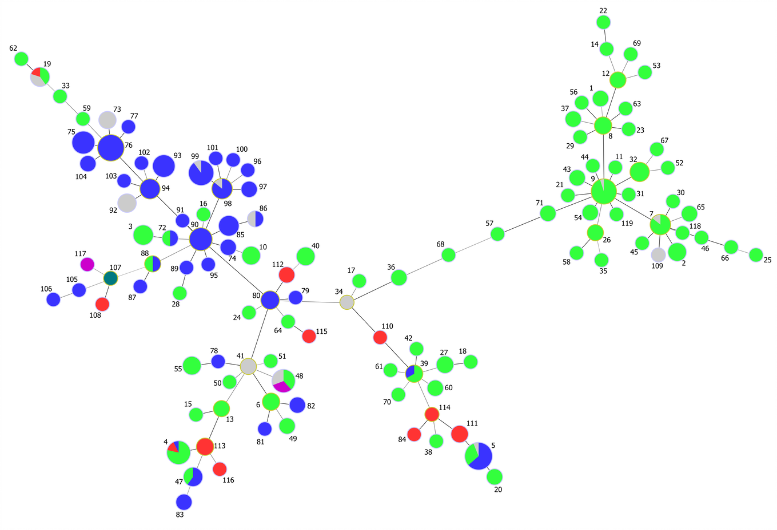
Fig. 1. The Full MLST location image is a complete minimum spanning tree of all the isolates, with node colours representing continents (Europe - Green; Australia - Blue; North America - Red; Asia - Purple; South America - Teal; NA - Grey). Ontario isolates belongs to ST4, ST110, ST111, ST112, ST113, ST114, ST115, and ST116. Courtesy of D. Bogema, Elizabeth Macarthur Agricultural Institute, NSW.
Discussion
Because of the limited number of isolates all data presented here are considered preliminary and more work is needed before any solid conclusions can be drawn. Our data indicates that isolates from the same premises are likely uniform having the same MLST, AMR and virulence genes patterns. Similar to other studies quite a diversity in MLST was observed for Ontario isolates (1,3). There are some indications, however, that, in general, isolates from the same geographical locations tend to cluster together (Fig. 1, D. Bogema personal communication). To confirm this hypothesis more isolates from Ontario need to be sequenced and included in MLST database in order to monitor their epidemiological relatedness. From the clinical perspective, currently there is no correlation between a specific MLST type and a virulence potential of the isolate. Most of the isolates sequenced in this study had all putative virulence genes as defined previously (1,2,3). For the 3 isolates that lacked some of these genes there was not enough information to determine if that made any difference in their clinical presentation.
The presence of antimicrobial resistance genes was not detected in all Ontario isolates but when detected resistance to tetracyclines and lincosamides was consistently present. Because of the lack of epidemiological data this study was not able to establish any links between antimicrobial use and presence of resistance genes.
To the best of our knowledge this is the first whole genome sequencing (WGS) study of Ontario E. rhusiopathiae isolates. Based on WGS results this study defined MLST profiles and detected putative virulence and AMR resistance genes of these isolates. In collaboration with the Australian group 7 new MLST patterns were added to E. rhusiopathiae typing scheme that are specific for Ontario isolates. At Animal Health Laboratory (AHL) we now have an established WGS database of 14 isolates which can be expanded by adding WGS of new isolates to monitor their epidemiological relatedness and to detect presence of resistance genes.
Acknowledgements
We are grateful to all veterinarians and producers for sample collection and submission, to Gallant Custom Laboratory for providing additional isolates and for OAHN network for financial support of this project. Special thanks to Daniel Bogema at Elizabeth Macarthur Agricultural Institute at NSW for classification of MLST of Ontario isolates and for preparing Fig. 1 and to Aparna Krishnamurthy for technical assistance with WGS.
References:
- Janßen, T., M. Voss, M. Kuhl, T. Semmler, H.-C. Philipp, and C. Ewans. 2015. A combinational approach of multilocus sequence typing and other molecular typing methods in unravelling the epidemiology of Erysipelothrix rhusiopathiae strains from poultry and mammals. Vet. Res. DOI 10.1186/s13567-015-0216-x
- Ogava, Y., T. Ooka, F. Shi, Y. Ogura, K. Nakayama, T. Hayashi, and Y. Shimoji. 2011. The genome of Erysipelothrix rhusiopathiae, the causative agent of swine erysipelas, reveals new insights into the evolution of Firmicutes, and the organism’s intracellular adaptations. J Bact 193:2959-2971.
- Sales, N., I. Marsh, L. Stroud, and B. Bowring. 2018. Innovation Grant: 2A-117 – Erysipelothrix rhusiopathiae Epi-interface, a new approach to the management of porcine erysipelas. Sequence assembly and analysis were done by Daniel Bogema.
- Zankari, E., H. Hasman, S. Cosentino, M. Vestergaard, S. Rasmussen, O. Lund., F.M. Aarestrup, and M.V. Larsen. 2012. Identification of acquired antimicrobial resistance genes. J Antimicrob Chemother 67:2640-2644.

KTT Record (from project proposal):
Please provide a list of publications/presentations that resulted from this project, and attach/email any PowerPoint presentations, abstracts from conferences, or links of presentations for posting on the OAHN site. If there is a banner/poster display from a student or other researcher for the project, please attach as well so we can highlight the work of the network.
KTT Plan | Status | Communications Date
Information will be disseminated via OAHN | Completed | February 28, 2019
Media Interview – Frances Anderson, Ontario Farmer / Ontario Hog Farmer | Completed – no article was published to our knowledge | March 5, 2019
Information will be disseminated via OAHN | Completed | June 8, 2020
Other KTT options (poster for OAHN display/promotion, journal article, etc.):  Presentation to OASV AGM  AHL Newsletter  Poster (OASV AGM, OAHN AGM) | Completed  To be completed  To be completed | June 24, 2020  September 2020  September 2020

